Work Orders – CO Inspections & Reporting

SUMMARY
Use this method to schedule the required CO inspections and generate reporting that can be submitted monthly to Best Western.
WHEN TO USE IT
• When you want to automate the CO inspection tasks
• Once a month generate the CO inspections report for submission to Best Western
IMPORTANT!
- Maintenance staff needs to be entered into the Mobile Team before beginning and an “All” section must be defined in Sections

- To create the report, you will need to download the CO Inspection Excel file available from the AutoClerk e-learning center.
TWO PARTS TO SET IT UP
PART 1 – Creating the Work Order
PART 2 – Creating the monthly report
ADDITIONAL HELP
Watch the Video Tutorial: Preventative Maintenance Tasks. It has similar examples and is available in the CleaMeNext Help Center under the Work Orders heading.
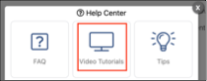
PART 1 – Create the Work Order for CO Inspections
1. Put the Work Order’s panel into Full Page View. Open the Menu > Work Orders
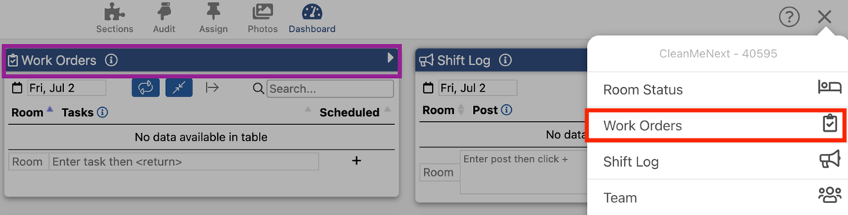

Or click on the blue bar title bar at the top of the Work Orders panel
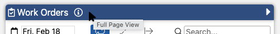

2. At the bottom of the page to the Room field and enter the first room number in the hotel (e.g. 101)

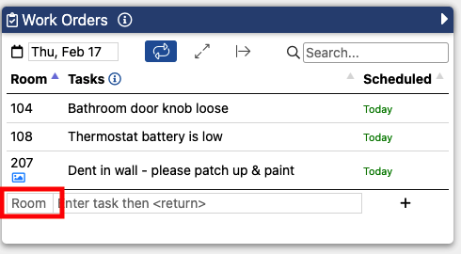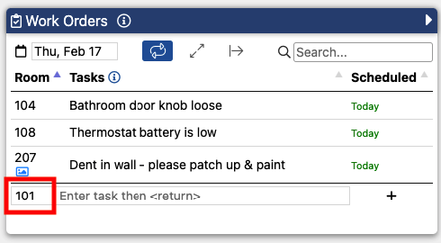

3. Next Enter a Task Name (e.g. Carbon Monoxide Inspection or Smoke Detector/CO Inspection, etc.) then hit return or +

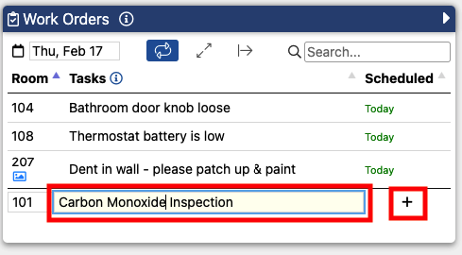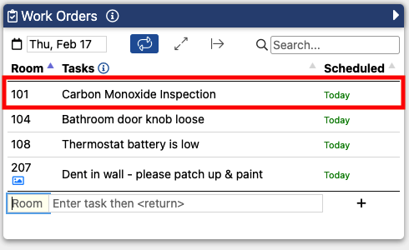

Now that the task is created it needs to be set up to repeat monthly.

4. Click on the Room Number next to the Carbon Monoxide Inspection task

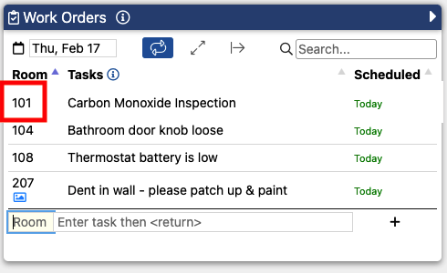

In the modifier panel select Repeat > Calendar Days > Monthly

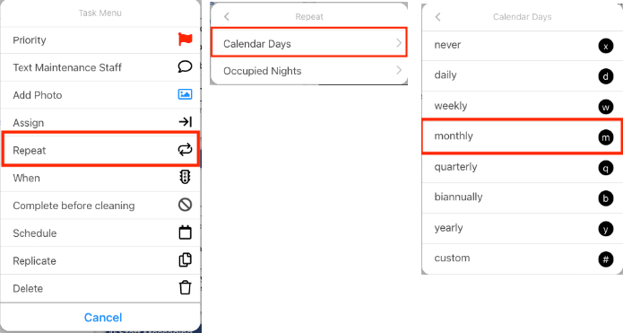

This Work Order task is set to repeat monthly as indicated by the “m” icon under the room number.

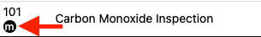

By default, this task will be assigned to the maintenance department (i.e. it will appear on every maintenance person’s work orders list.)

If you prefer to assign this task to a specific person on your staff, click on the room number and in the modifier panel Assign > Maintenance > Select the team member you want to perform the task.

5. To replicate this task to all the rooms in the hotel, click on the room number and in the modifier panel Replicate > All

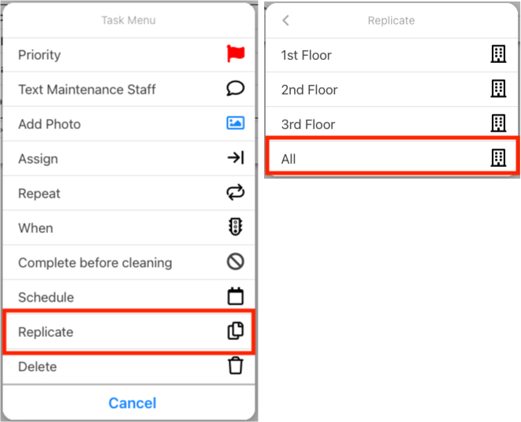

The task is now replicated to all the rooms in the hotel. The task should appear in the Work Orders panel for each room.

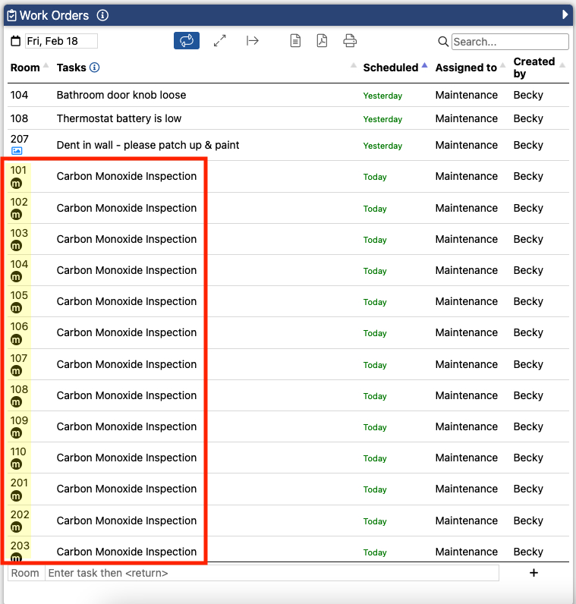

PART 2 – Creating the Monthly CO Report for Best Western

1. Download the CO Inspection .xlsx template from the Auto-Clerk e-Learning Center

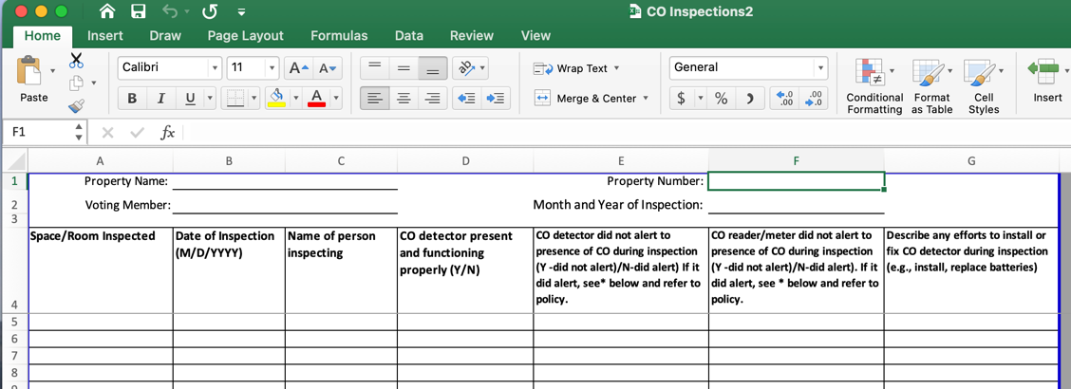

2. At the end of each month view the Work Order’s panel in Full Page View Menu > Work Orders

3. Upper left click on Calendar

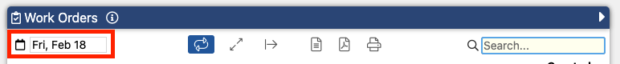

From the calendar date picker select the first day of the month

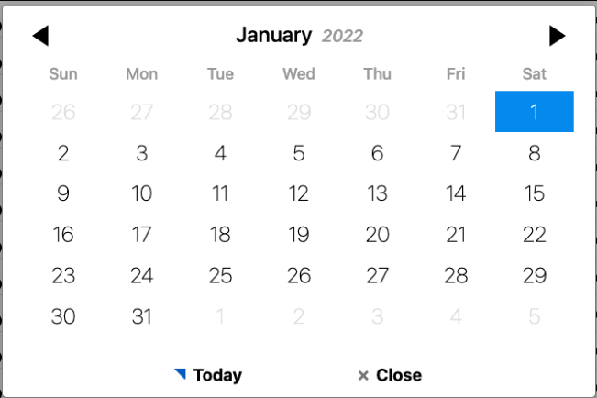

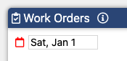

4. In the Search bar enter a key word or the name of the task in the search box

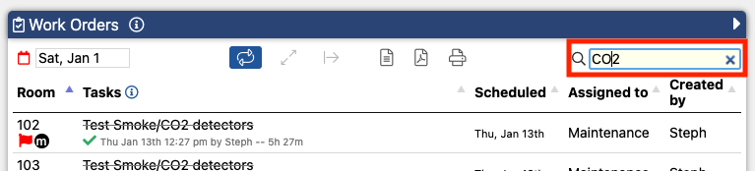

5. Next export the table by clicking on the Excel icon

The file will download to your computer. Be sure to note where you saved the file or look for the file in the “downloads” folder of your computer.

6. Open the downloaded file in Excel.

7. Open the CO_Inspections2.xls file downloaded from the AutoClerk e-Learning center (see page 1).

8. Select and copy then paste the location, date and person completing the inspection in the appropriate columns and complete the informational fields at the top.

9. Once completed, save the file and send it to Best Western.

